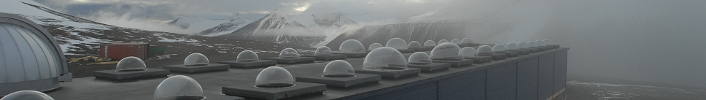
The Kjell Henriksen Observatory (KHO) 2014 - 2015
Fred Sigernes, Lisa Baddeley, Dag Lorentzen, Margit Dyrland, Silje Eriksen Holmen, Xiangcai Chen, Pål Gunnar Ellingsen, Noora Partamies and Mikko Syrjäsuo
The University Centre on Svalbard (UNIS), N-9171 Longyearbyen, Norway
Birkeland Centre for Space Science (BCSS)
Abstract
The following is a summary for the activity at the Kjell Henriksen Observatory (KHO) for the 2014-2015 season. The current active personnel of the observatory are presented together with the operational instruments. A brief summary of the progress of the new Super Dual Auroral Radar Network (SuperDARN) radar is given in addition to project highlights from the Cusp Region EXperiment (C-REX) rocket mission and the Total Solar Eclipse campaign.

The observatory crew
The current crew of KHO is listed below. F. Sigernes headed and had the daily operational responsibility together with Mikko Syrjäsuo.
Name | UNIS position | E-mail
Fred Sigernes | Professor, Optics and atmospheric Research,  Head of The Kjell Henriksen Observatory | freds@unis.no
Mikko Syrjäsuo | Head engineer | mikkos@unis.no
Noora Partamies | Associate Prof. Middle atmospheric physics | noorap@unis.no
Dag Arne Lorentzen | Professor, Upper polar atmosphere  Head of the SuperDARN radar project | dagl@unis.no
Lisa Baddeley | Associate Professor, Radar applications,  Head of the Doppler Pulsation Experiment | lisab@unis.no
Margit Dyrland | Post Doc, Middle atmospheric physics | margitd@unis.no
Silje Eriksen Holmen | PhD candidate, Middle atmospheric physics | siljeh@unis.no
Xiangcai Chen | PhD candidate, Aurora physics | xiangcai.chen@unis.no
Pål Gunnar Ellingsen | Post Doc, Space physics | pale@unis.no
Table 1. The Kjell Henriksen Observatory crew (2014-2015).
Our Norwegian Construction and Property Management Department in Longyearbyen contact is Tommy Frantzen (tofr@statsbygg.no).

Operational instrumentation
The instruments at KHO are grouped into mainly five categories (#):
- All-sky cameras and narrow ﬁeld of view imagers,
- Meridian scanning photometers,
- Spectrometers / spectrographs
- Scanning / imaging interferometers
- Radio or non-optical instruments
Table 2 below lists all of the instruments according to institution and category (#).
 | Instrument | Institution | # | Country
1 | All-sky imager | University of Oslo (UiO) | A | Norway (NO)
2 | All-sky intensified video camera | University Centre in Svalbard (UNIS) | A | NO
3 | All-sky intensified camera | Finnish Meteorological Institute (FMI) | A | Finland
4 | All-sky color camera | University College London (UCL) | A | England
5 | All-sky video camera | UNIS | A | NO
6 | All-sky DSLR camera | UNIS | A | NO
7 | All-sky Airglow Imager | UNIS | A | NO
8 | Auroral meridian spectrograph | National Institute of Polar Research (NIPR) | C | Japan
9 | CCD spectrograph | Embry Riddle Aeronautical University (ERAU) | C | USA
10 | Spectrographic Imaging Facility | The University of Southampton/UCL | C | England
11 | Meridian-Scanning Photometer | University of Alaska Fairbanks/UNIS | B | USA/NO
12 | 1m S.Ebert-Fastie spectrometer | University of Alaska Fairbanks/UNIS | C | USA/NO
13 | 1m G.Ebert-Fastie spectrometer | University of Alaska Fairbanks/UNIS | C | USA/NO
14 | 1/2m B.Ebert-Fastie spectrometer | University of Alaska Fairbanks/UNIS | C | USA/NO
15 | 1/2m W.Ebert-Fastie spectrometer | University of Tromsø (UiT) | C | NO
16 | Michelson Interferometer | ERAU | D | USA
17 | Fabry-Perot interferometer | UCL | D | England
18 | Scanning Doppler Imager | UCL | D | England
19 | Monochromatic Auroral Imager | Polar Research Institute of China (PRIC) | A | China
20 | All-sky Airglow Imager | University of Electro-Communications (UEC) | A | Japan
21 | Fluxgate magnetometer | UiT | E | NO
22 | 2-axis search coil magnetometer | Augsburg College/Univ. of New Hampshire | E | USA
23 | Fluxgate magnetometer | PRIC | E | China
24 | Auroral Radio Spectrograph | Tohoku University | E | Japan
25 | HF acquisition system | Institute of Radio Astronomy/UiT | E | Ukraine/NO
26 | 64xBeam Imaging Riometer | Danish Meteorological Institute (DMI)/UiT | E | Denmark/NO
27 | Balloon Telemetry Station | Nobile/Amundsen - Stratospheric Balloon Center/Italian Space Agency | E | US/Italy
30 | Hyperspectral tracker (Fs-Ikea) | UNIS | C | NO
31 | All-sky hyperspectral camera | UNIS | C | NO
32 | Narrow field of view tracker | UNIS | A | NO
33 | Scintillation and TEC receiver | University of Bergen (UiB) | E | NO
34 | Automatic weather station | UNIS | E | NO
35 | 4xWEB cameras (safety) | UNIS | A | NO
36 | Celestron 4m Telescope | UNIS | A | NO
37 | Internet radio link - Janssonhaugen | NORSAR | E | NO
Table 2. Instruments at the Kjell Henriksen Observatory (2014-2015).

During the auroral winter season from November to the end of February, 27 optical instruments operate 24 hours a day. The 10 non-optical instruments run all-year-round 24 hours a day. A detailed description of the performance and the scientiﬁc objective of each instrument are found online. 21 different institutions from 9 nations are present at KHO. A map of where the instruments are located can be downloaded here. Note that out of 29 instrument domes; only four are currently not in use.
Teaching and courses  KHO serves as the main laboratory for hands on training and teaching of students in the Space physics group at UNIS.  Fig. 1 show students on field work using both the EISCAT radar and KHO. They used state-of-the-art facilities to do in-situ observations of the aurora.  The following 4 courses have used KHO as part of field work: |  | 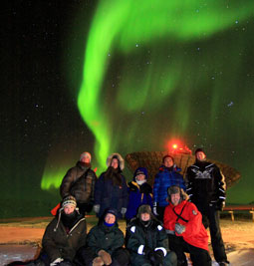  Fig.1. AGF-345 students at Breinosa. Photo: Njål Gulbrandsen
Code | Course name |  | ECTS
AGF-216 | The Stormy Sun and the Northern Lights |  | 5
AGF-301/801 | The Upper Polar Atmosphere |  | 15
AGF-304/804 | Radar Diagnostics of Space Plasma |  | 15
AGF-345/845 | Polar Magnetospheric Substorms |  | 10
Table 3. UNIS courses using KHO as laboratory (2014-2015)
A grand total of 45 ECTS (European Credit Transfer and Accumulation System) have been taught.
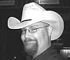 | A new protonic is born! Jeff Morgan Holmes has defended at the University of Oslo (UiO) his PhD titled: The Protonics project: distributed observations of auroral dayside Doppler-shifted hydrogen emissions. KHO salute you!  More info: [1][2]
  (1) Dr. Holmes, I presume?
Graduated students

 | Congratulation to Master Kinga Albert! The thesis is called: Svalpoint: A multi-track optical pointing system. It enables us at KHO to track any object on the night sky with multiple instruments, simultaneously. Her work opens new opportunities for us and we really look forward to start using the system. More info:[3]
  (2) Master Kinga

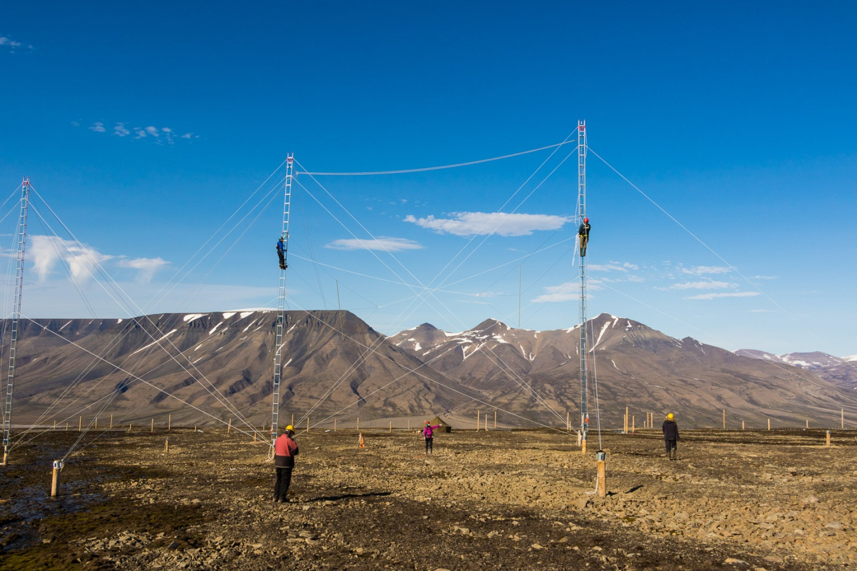Fig. 2. The SuperDARN radar under construction. Photo: Mikko Syrjäsuo/UNIS.
The Svalbard SuperDARN (Super Dual Auroral Radar Network) HF Radar
The project is currently on target to have the facility operational by October 2015. Planning permission for the facility was awarded in May 2014 and construction on site began in October 2014. The antenna masts were mounted in August 2015. Mains power and optical fiber connections are also installed. The transmitter units will arrive soon and will be connected at the site in September 2015.
UNIS held Norway’s first international SuperDARN meeting in May 2014. We had 50 upper atmospheric / auroral scientists from 11 countries attend the meeting. See more info here: [4].
In addition a new HF transmitter is deployed to Hornsund to study small scale ionospheric and gravity waves. The receiver will be deployed at KHO this fall.
Royal visit 2
Her Royal Majesty Queen Sonja of Norway revisited KHO 5th of February, 2015. Together with friends she inspected key instruments and was given an update on our research on aurora and airglow. The global weather machine and solar impacts was also discussed in relation to possible climatic changes. We are very happy for the Queens interest in our work.

The Cusp Region EXperiment (C-REX)
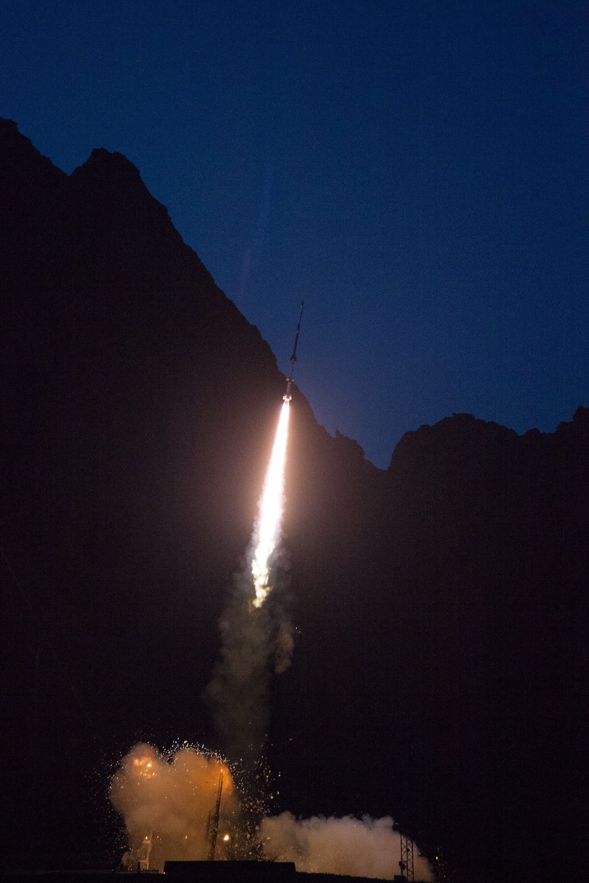  Fig. 3. Launch of the C-REX rocket from Andøya. Photo: Brea Reeves. | KHO was a central part of the Cusp Region EXperiment (C-REX), a NASA sounding rocket mission that released a large constellation of artificial clouds into the ionosphere above the Greenland Sea. The rocket was launched from Andøya Space Centre at 08:05 UT on 24th of November, 2014.  See more info about the rocket mission here: [5][6]  The geomagnetic condition was low with a Kp-index = 1 for the event. The rocket was launched into an area dominated by stable cusp auroral arcs.  The rocket ejected 24 sub-payload canisters loaded with Barium and Strontium vapor. When released and illuminated by the Sun, both ion and neutral barium emission lines appears visible to the human eye.
Strontium was added to the barium mixture to enhance the neutral drift detection. 10 cloud releases were detected from KHO, Ny-Ålesund and from the airborne carrier (all stations).
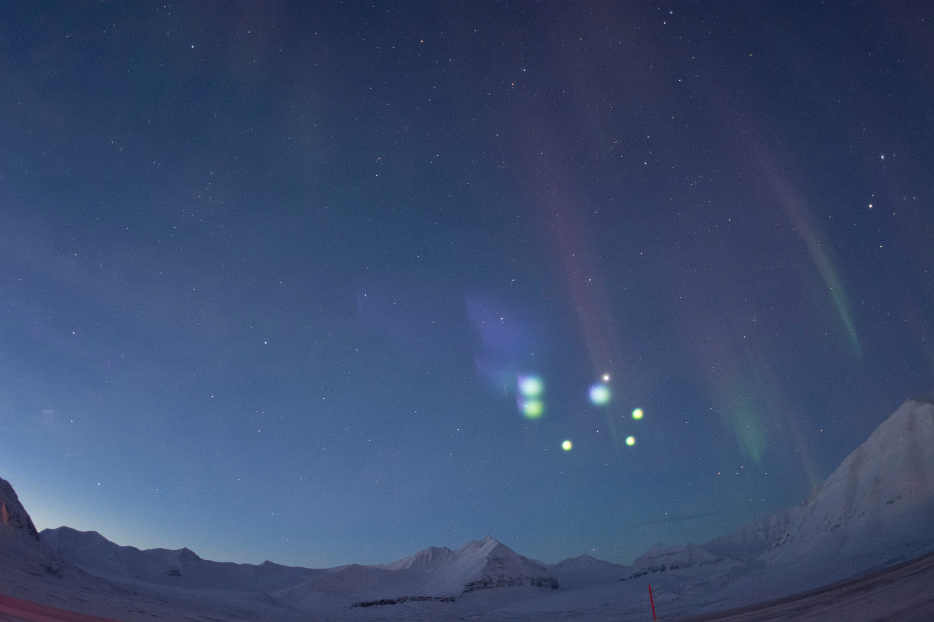
Fig. 4. C-REX releases as seen from Ny-Ålesund. Photo: Manbharat Dhadly.
Fig. 5. NORUSCA II all-sky color composite images from the Kjell Henriksen Observatory (KHO), 24.11.2014. The Red, Green and Blue color channels are from center wavelengths 6300, 5577 and 4861 Å, respectively. Labels (A) to (D) represent time from 08:14 to 08:17 UT. Jupiter is marked with arrow (1) in panel (A). Arrow (2) in panel (B) marks the first releases of the artificial clouds from the C-REX rocket.
Large velocity difference between the neutral and ions has been detected, which is believed to produce Joule heating. No clear indication of upwelling is detected yet. High altitude puffs seems to disperse quickly. A new mission called C-REX2 is proposed to address these issues in more detail in order to fully explain the high density anomaly in the cusp thermosphere region. F. Sigernes is invited as Co-I to this mission.
The ICI-4 rocket experiment
AGF-304/804 Master and PhD students provided radar support for the University of Oslo sounding rocket named ICI-4 that was launched successfully from Andøya Space Centre at 23.06 LT on 20th of February, 2015. See more info here: [7].
The total solar eclipse campaign on Svalbard 2015

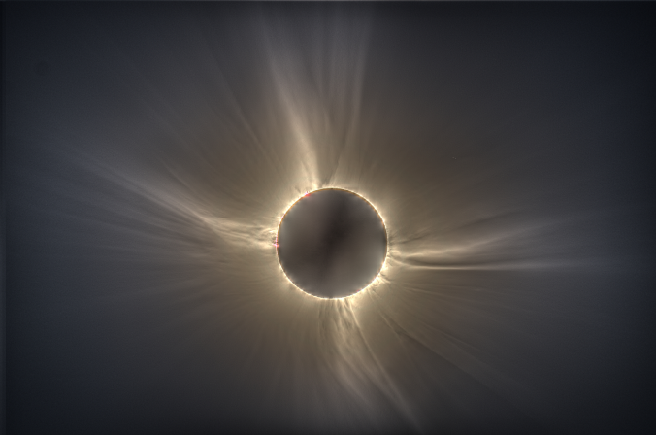  Fig. 6. High Dynamic Range (HDR) image of the total eclipse composed by 20 images from a 400 mm telescope at Nordlysstasjonen in Adventdalen. | The total solar eclipse on Friday 20th March 2015 started in the western Atlantic, 650 km west of Canada's Labrador coast and 450 km south of the southern tip of Greenland. It then raced across the Atlantic ocean touching land at only two places: the Faroe Islands between Scotland and Iceland, and the Svalbard Archipelago (particularly, Spitsbergen Island).  In Longyearbyen, Svalbard, the first contact, the start of the partial eclipse, started at 09:11:53UT. About 59 minutes later, at 10:10:43UT second contact took place, marking the start of totality.

After a mere 2 minutes and 27 seconds, third contact occurred at 10:13:10UT, which marked the end of totality and the disappearance of the corona. This was followed by a partial phase of about another 59 minutes before fourth contact and the end of the solar eclipse at 11:12:21UT.

Our campaign was divided into 7 parts using the old Auroral Station in Adventdalen, KHO, UNIS in Longyearbyen and the Dornier at Lufttransport AS. Table 4 lists the PI’s and their objectives.

 | Objective | Site | PI
1 | Teaching | UNIS | P. Brekke
2 | Public outreach | UNIS | P, Brekke
3 | Coronal imaging | Nordlysstasjonen | P.G. Ellingsen
4 | Auroral measurements | KHO | S.E. Holmen
5 | Airborne hyperspectral imaging | Dornier | F. Sigernes
6 | Coronal dynamics and spectra | UNIS | J. Pasachoff
7 | High resolution spectra | Nordlysstasjonen | S. Habbal
Table 4. The total eclipse team at UNIS. Nordlysstasjonen refers to the old auroral station in Adventdalen.

The UNIS course AGF-216: The Stormy Sun and Northern Lights, was offered to students and local people from Longyearbyen. High resolution ground-based spectral measurements were out by a team from the Institute for Astronomy at the University of Hawaii. They used the old station in Adventdalen. Coronal dynamics was studied by a group from Williams College, Massachusetts. KHO was operative to see if we were lucky to detect aurora. In addition, an airborne experiment was conducted to image the event with a new hyperspectral camera. For more info on the campaign see [8].

Our data analyzes show promising results and will be presented at the AGU 2015 fall meeting in San Fransisco (invited talk). Two highlights are presented in Figs. 7 and 8.
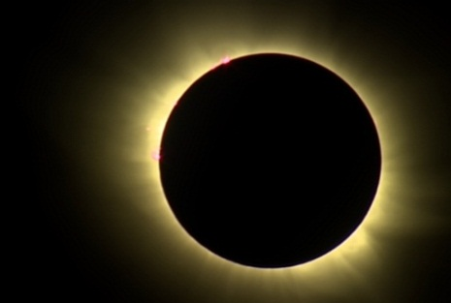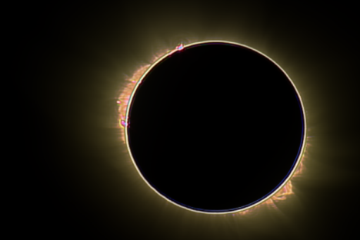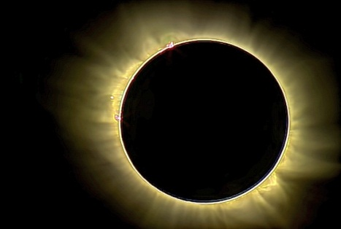
Fig. 7. Accumulated video highpass cascade filter technique applied to live broadcast from NRK of the total solar eclipse on Svalbard 2015. Left: Stabilized summation of 448 video frames (raw image). No filter applied. Middle: Accumulated frames with 5x5 pixel highpass cascade filter. Right: Accumulated 3x3 highpass cascade image fused with raw image.

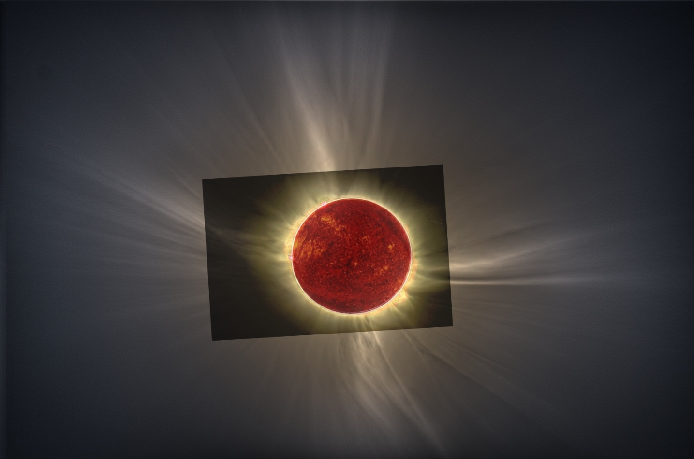
Fig. 8. High Dynamic Range (HDR) image fused with the highpass cascade video sequence from NRK and the Solar Dynamics Observatory (SDO) image at 304 nm.
KHO was also operative, but did not detect any dayside auroral signatures. The background sky condition was too bright during totality for the auroral cameras. The airborne hyperspectral data will be used to cluster and classify active solar regions with prominences from the background continuum. The video from the plane of the eclipse shadow was published by several media companies worldwide.

Intercalibration workshop
In order to secure our long term trend data we aim to continue our work with the Nordic optical intercalibration workshops. Our laboratory spectrometer will travel to Sodankylä Observatory in fall 2015 to check and verify the Swedish and Finnish calibration sources.

The near future …
The length of the optical season has been doubled from November to March due to the increased activity that the Birkeland Centre for Space Science (BCSS) represents. This also doubles the logistical costs including power consumption, water supply and snow cleaning of the road up to the observatory from Mine 7.
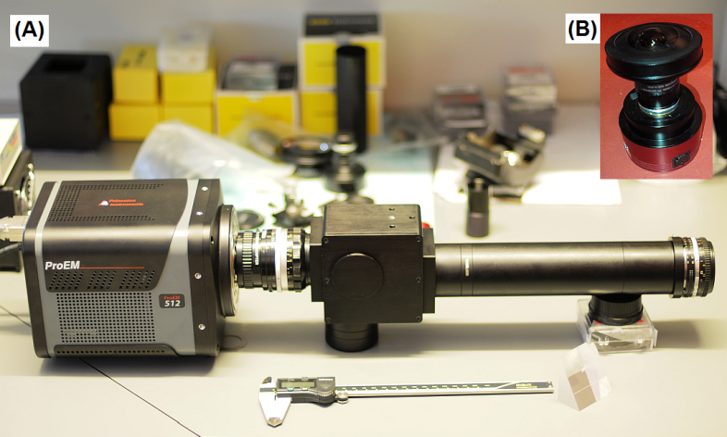  Fig. 9. New instruments at KHO 2015. Panel (A): Meridian Imaging Svalbard Spectrograph (MISS). Panel (B): The ZWO ASI174MC F/1.4 all-sky color camera. | The need to operate instrument during periods with high background sky illumination when the moon is up forces us to develop instruments with increased dynamic range without damage to the detectors. The arrival of new EMCCD and CMOS detectors enables us to construct and test new instruments that can operate under any background sky conditions including scattered light pollution. A new Meridian Imaging Svalbard Spectrograph (MISS) will be tested next season and compared with our Meridian Scanning photometer (MSP).
The MISS will have no moving parts using a high sensitive CCD (Sony ICX825 EXview). In addition, a new low cost F/1.4 color all-sky camera with the new back illuminated CMOS (Sony IMX174) sensor designed to operate especially for Sun and Moon imaging will be tested. The camera is a candidate for a plan to deploy a large network of cameras in Scandinavia to image and forecast aurora.
The two NORUSCA hyperspectral all-sky cameras are now calibrated in intensity [9]. The Russian camera will be installed at The Barentsburg Auroral Station in September. The Space physics group at UNIS will also attend the 42nd Annual European Meeting on Atmospheric Studies by Optical Methods (42AM), Hermanus, Western Cape, South Africa, September 14-18, 2015.
The internal research funding of UNIS is used to acquire sensors and parts for these test instruments. It enables us to preserve the instrumental momentum and helps us keep track of new technology as it arrives. It seeds our research plans and is as a consequence strategically important to us. This must not be under estimated compared to our external funding which is more tied up or locked to predefined proposal tasks.

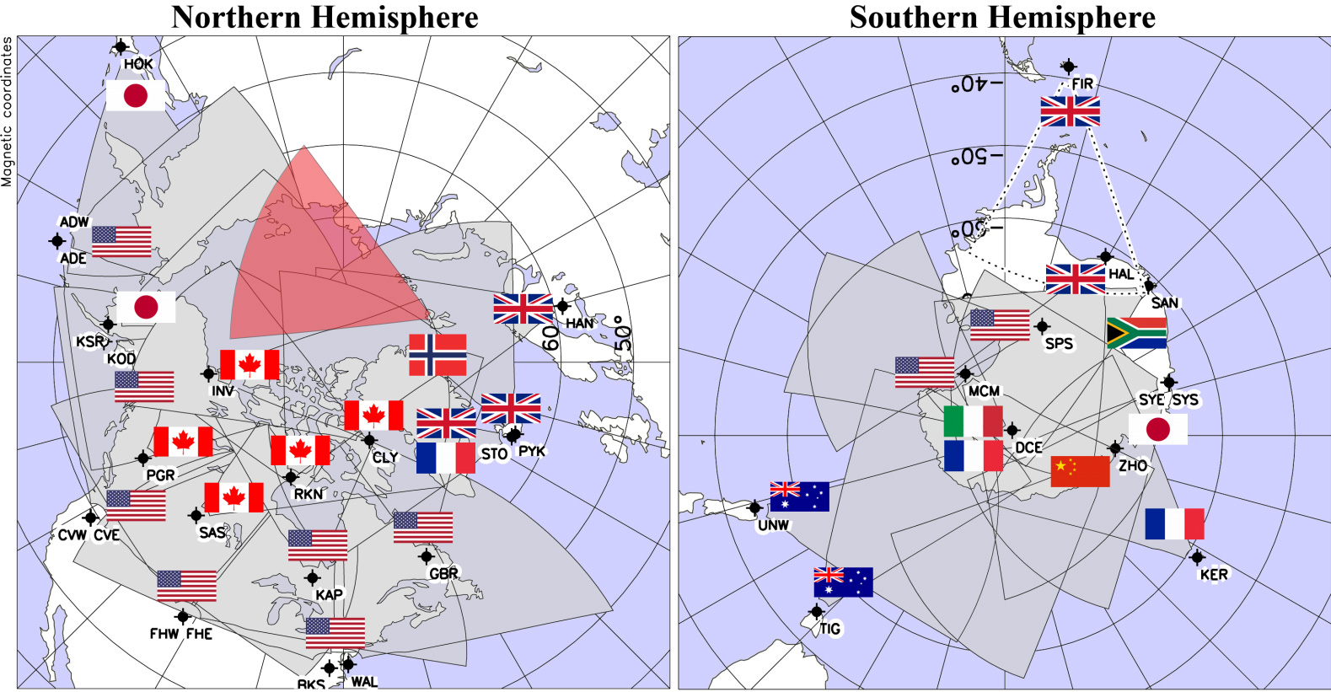 Fig.10. The SuperDARN radar network. The new Svalbard radar’s field of view is mapped with red. Illustration by Virginia Tech.
The new SuperDARN radar will map ionospheric activity East of Svalbard along the auroral oval several hours prior to it enters the field of view of the optical instruments at KHO. The latter should in theory improve our auroral forecast service.
The next rocket campaign that KHO supports is the RENU2 (Rocket Experiment for Neutral Upwelling 2), which is planned to be launched from Andøya in November – December, 2015. We also support as collaborators and Co-I the rocket proposals to NASA named VISION2 and C-REX2, respectively.
Conclusion
The 2014 – 2015 season has been very active with two major events. The C-REX rocket launch and the total solar eclipse generated high activity and public interest.

Graduated students
- Kinga Albert, Master, August 2014, Department of Computer Science, Electrical and Space Engineering Division of Space Technology, Kiruna, Luleå University of Technology, SvalPoint: A Multipoint Optical Tracking System.

- Jeff Holmes, PhD, August 2014, The Protonics project: distributed observations of auroral dayside Doppler-shifted hydrogen emissions, University of Oslo, Norway.
Public outreach
Numerous presentations, visits and interviews have been conducted at KHO. At some point, we stopped counting. A media seek could be done by personnel that are professionals. The total eclipse campaign generated 85 news articles alone (source: Meltwater). Live streaming of the event by NRK was followed by more than 600 000 people. The number for TV2 is not known.
Publications
- E.R. Reisin, J. Scheer, M.E. Dyrland, F. Sigernes, C.S. Deehr, C. Schmidt, K. Höppner, M. Bittner, P.P. Ammosov, G.A. Gavrilyeva, J. Stegman, V.I. Perminov, A.I. Semenov, P. Knieling, R. Koppmann, K. Shiokawa, R.P. Lowe, M.J. López-González, E. Rodríguez, Y. Zhao, M.J. Taylor, R.A. Buriti, P.J. Espy, W.J.R. French, K.-U. Eichmann, J.P. Burrows, and C. von Savigny, Traveling planetary wave activity from mesopause region airglow temperatures determined by the Network for the Detection of Mesospheric Change (NDMC), Journal of Atmospheric and Solar-Terrestrial Physics, Vol. 119, 71-82, 2014.

- F. Sigernes, S. E. Holmen, D. Biles, H. Bjørklund, X. Chen, M. Dyrland, D. A. Lorentzen, L. Baddeley, T. Trondsen, U. Brändström, E. Trondsen, B. Lybekk, J. Moen, S. Chernouss, and C. S. Deehr, Auroral all-sky camera calibration, Geosci. Instrum. Method. Data Syst. Discuss., 4, 515-531, 2014.

- Holmes, J. M., Johnsen, M. G., Deehr, C. S., Zhou, X. Y. and Lorentzen, D. A., Circumpolar ground-based optical measurements of proton and electron shock aurora, J. Geophys. Res., 119, DOI: 10.1002/2013JA019574, 2014.

- C. van der Meeren, K. Oksavik, D. Lorentzen, J. Moen, V. Romano, GPS scintillation and irregularities at the front of an ionization tongue in the nightside polar ionosphere, J. Geophys. Res, DOI: 10.1002/2014JA020114, 2014.

- Holmen, S.E., M.E. Dyrland, and F. Sigernes (2014), Mesospheric temperatures derived from three decades of hydroxyl airglow measurements from Longyearbyen, Svalbard (78°N), Acta Geophysica, Vol. 62, No 2, pp. 302-315, doi: 10.2478/s11600-013-0159-4.

- Holmen, S. E., M. E. Dyrland, and F. Sigernes (2014), Long-term trends and effect of solar cycle variations on mesospheric winter temperatures over Longyearbyen, Svalbard (78°N), J. Geophys. Res. Atmos., 119, doi: 10.1002/2013JD021195.

- F. Pitout, A. Marchaudon, P.-L. Blelly, X. Bai, F. Forme, S.C. Bucher and D. Lorentzen, Swarm and ESR observations of the ionospheric response to field-aligned currents: electrodynamics and thermodynamics, GRL, 42, DOI: 10.1002/2015GL064231, 2015.

- Tereshchenko, E. D., R. Y. Yurik, L. J. Baddeley, Stimulated electromagnetic emission polarization under different polarizations of pump waves, Ann. Geophysicae, 33, 295 - 300, 2015

- Shi, R., Z. J. Hu, B. Ni, D. Han, X. C. Chen, C. Zhou, and X. Gu (2014), Modulation of the dayside diffuse auroral intensity by the solar wind dynamic pressure, Journal of Geophysical Research: Space Physics, 119(12), 10,092-010,099.

- Bjoland, L. M., X. Chen, Y. Jin, A. S. Reimer, Å. Skjaeveland, M. R. Wessel, J. K. Burchill, L. B. N. Clausen, S. E. Haaland, and K. A. McWilliams (2015), Interplanetary magnetic field and solar cycle dependence of Northern Hemisphere F-region joule heating, Journal of Geophysical Research: Space Physics, 120(2), 1478-1487, doi:10.1002/2014ja020586.
Conferences – talks – presentations
- F. Sigernes, SuperDARN workshop, Color matching the aurora, Longyearbyen, Norway, May, 2014.

- Fred Sigernes, Jyrki Mattanen, Dag Arne Lorentzen, Sergey Chernouss and Charles Sterling Deehr, Color matching the aurora, The 41st Annual European Meeting on Atmospheric by Optical Methods, Stockholm, Sweden, August 17-21, 2014.

- V. Roldugin, F. Sigernes, A. Roldugin, S. Pilgaev, The electron and proton precipitation in Scandinavian sector during SC on 24 January 2012 (Poster), The 41st Annual European Meeting on Atmospheric by Optical Methods, Stockholm, Sweden, August 17-21, 2014.

- D.A. Lorentzen, F. Sigernes, K. Oksavik, L. Baddeley, J. M .Moen, A validation of the UNIS auroral oval model-preliminary results, Birkeland March meeting, 2014.

- D.A. Lorentzen, L. Baddeley, F. Sigernes, M. Dyrland, J.M. Moen and P. Brekke, An update on the Svalbard SuperDARN radar, SuperDARN workshop, Color matching the aurora, Longyearbyen, Norway, May, 2014.

- D.A. Lorentzen, Fred Sigernes, Lisa Baddeley, Margit Dyrland, Jøran Moen, Pål Brekke, Kjellmar Oksavik, Xiangcai Chen, Silje Holmen, The Kjell Henriksen Observatory – a window into space, Studietur Nord, August, 2014.

- D.A. Lorentzen, Space weather and its implications, Studietur Nord, August, 2014.

- Baddeley, L. J, Space Physics and Upper Atmospheric Research on Svalbard, Svalbard Science Forum Workshop - New technology for bridging the arctic knowledge gaps, Ven, Sweden, October 2014

- Baddeley, L. J., D. A. Lorentzen, K. Oksavik, The Sun’s Influence on the Earth’s Atmosphere, ConocoPhillips Northern Area Research Program, Stavanger, Norway, June 2014

- Baddeley, L. J., A New Radar Facility on Svalbard, Studietur Nord, August 2014

- Baddeley, L. J., A New Radar Facility on Svalbard, Presentation to the standing committee on Justice of the Parliament of Norway, July 2014

- D.A. Lorentzen, Fred Sigernes, Lisa Baddeley, Margit Dyrland, Jøran Moen, Pål Brekke, Kjellmar Oksavik, Xiangcai Chen, Silje Holmen, The Kjell Henriksen Observatory – a window into space, Presentation to the standing committee on Justice of the Parliament of Norway, July 2014

- S.E. Holmen, 2nd ARISE Workshop, 25-27 March 2014, University of Firenze, Italy. Poster: “Case study of a wave event observed in OH airglow emissions over Longyearbyen, Svalbard (78°N), 24 January 2012”.

- Chen, X. et al., Statistical comparison of HF radar backscatter boundaries with auroral particle precipitation boundaries on the dayside, SuperDARN workshop 25-30th May, UNIS Svalbard, 2014

- Gerard Fasel, Megan Rawie, Julia Flicker, Mashaer Alyami, Alexandra Angelo, Sarah Bender, David G. Sibeck, Fred Sigernes, Dag A. Lorentzen, and David Green, Dayside Auroral Activity During Solar Maximum and Minimum Periods, AGU Fall Meeting, December 15 -19, San Francisco, USA, 2014.

- V. Roldugin, F. Sigernes, A. Roldugin, S. Pilgaev, The electron and proton precipitation in Scandinavian sector during SC on 24 January 2012, The 41st Annual European Meeting on Atmospheric by Optical Methods, Stockholm, Sweden, August 17-21, 2014.

- D.A. Lorentzen, Fred Sigernes, Lisa Baddeley, Noora Partamies, Pål Gunnar Ellingsen, Jøran Moen, Pål Brekke, Kjellmar Oksavik, Xiangcai Chen, Silje Holmen, The Kjell Henriksen Observatory – a window into space, presentation for acting Minister of Education and Research, Elisabeth Aspaker, April, 2015.

- D.A. Lorentzen, L. Baddeley, F. Sigernes, J. Moen, P. Brekke M. Syrjäsuo, A short update on the Svalbard SuperDARN radar, The SuperDARN workshop, Leicester, UK, 2015.
- Nosikova, N., N. V. Yagova, V. A. Pilipenko, O. V. Kozyreva, D. Lorentzen, L. Baddeley, Does a 'substorm precursor' exist in the polar cap, EGU meeting , Vienna, 2015

- Baddeley, L., D. A. Lorentzen, Project Update: Energy Transfer from the Sun to the Earth, ConocoPhillips / Lundin High North Research Program meeting, Stavanger, June 2015

- N. Partamies and L. Baddeley Space Physics Research on Svalbard, Studietur Nord, Svalbard, July 2015

- L. Baddeley, High North Study Tour for the European Commission - EISCAT 3D and auroral research on Svalbard, July 2015

- Chen, X., D.A. Lorentzen, J. Moen, K. Oksavik, L.J. Baddeley, Simultaneous ground-based optical and HF radar observations of the ionospheric footprint of open/closed field line boundaries along meridian line, SuperDarn Meeting, Leicester, June 2015

- Pål Brekke, Arne Danielsen, Jay Pasachoff and Shadia Habbal, Solar Eclipse Warm up, Møysalen, UNIS, March 19, 2015.

- Fred Sigernes, Lisa Baddeley, Dag Lorentzen, Margit Dyrland, Silje Eriksen Holmen, Xiangcai Chen and Pål Gunnar Ellingsen, The Kjell Henriksen Observatorium?, The HM Queen visit to KHO, February 5, 2015

- Mark Conde, Miguel Larsen, Donald Hampton, Manbharat Dhadly, Jason Ahrns, Anasuya Aruliah, Yoshihiro Kakinami, Barrett Barker, Andrew Kiene, Fred Sigernes, and Dag Lorentzen, The C-REX Sounding Rocket Mission, EGU General Assembly, 17 -17 April, Vienna, Austria, 2015.

- P. G. Ellingsen, Aurora Borealis - One of the Seven Natural Wonders, Diplomatreisen, UNIS, June, 2015.

